Challenge Lab: Marketing Dashboard

© 2024 Amazon Web Services, Inc. or its affiliates. All rights reserved. This work may not be reproduced or redistributed, in whole or in part, without prior written permission from Amazon Web Services, Inc. Commercial copying, lending, or selling is prohibited. All trademarks are the property of their owners.

Note: Do not include any personal, identifying, or confidential information into the lab environment. Information entered may be visible to others.

Corrections, feedback, or other questions? Contact us at [*AWS Training and Certification*](https://support.aws.amazon.com/#/contacts/aws-training).

**Lab overview**

The AnyCompany Software sales team is using the new sales dashboard to drive their strategy for the next year. Now that the sales dashboard is published and in production, you have been asked to develop a similar dashboard for the marketing team based on the proof of concept you shared with them yesterday. The marketing team uses several different campaign events to sell a wide range of AnyCompany Software products. They want to track the success of the campaigns using the website metrics to find which campaign worked the best. They also want a general overview of their website performance and social media presence on the Social 1 and Social 2 apps.

In this lab, you join three datasets together, create a new marketing dashboard, and add interactivity. You also perform advanced data calculations and fine-tune the machine learning implementation and strategy in the dashboard visualizations.

**Caution:** This is a challenge lab, a lab that does not include full step-by-step instructions on how to complete every task. Generalized walkthroughs are provided in the appendix for each kind of task you may want to complete as you develop your marketing dashboard.

OBJECTIVES

By the end of this lab, you should be able to do the following:

* Join three or more data sources together into one dataset.
* Create an analysis from a new dataset.
* Implement interactivity and customize formatting.
* Perform advanced data calculations.
* Integrate machine learning at multiple levels.

DURATION

This lab requires approximately *180* minutes to complete.

ICON KEY

Various icons are used throughout this lab to call attention to different types of instructions and notes. The following list explains the purpose for each icon:

* **Expected output:** A sample output that you can use to verify the output of a command or edited file.
* **Note:** A hint, tip, or important guidance.
* **Caution:** Information of special interest or importance (not so important to cause problems with the equipment or data if you miss it, but it could result in the need to repeat certain steps).
* **Consider:** A moment to pause to consider how you might apply a concept in your own environment or to initiate a conversation about the topic at hand.
* **Hint:** A hint to a question or challenge.
* **Task complete:** A conclusion or summary point in the lab.

**Start lab**

1. To launch the lab, at the top of the page, choose Start lab.

**Caution:** You must wait for the provisioned AWS services to be ready before you can continue.

1. To open the lab, choose Open Console.

You are automatically signed in to the AWS Management Console in a new web browser tab.

**WARNING:** **Do not change the Region unless instructed.**

COMMON SIGN-IN ERRORS

**Error: You must first sign out**

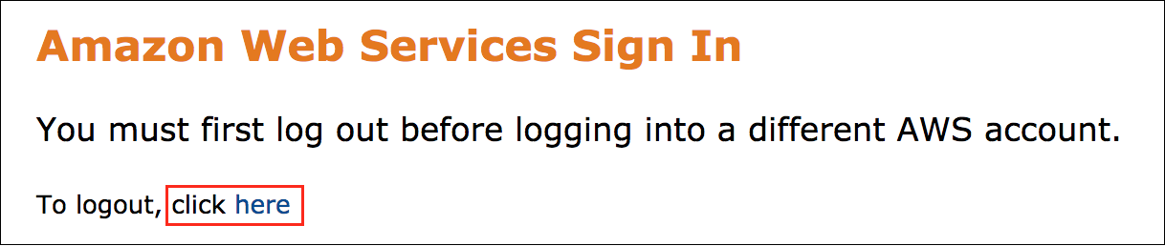

If you see the message, **You must first log out before logging into a different AWS account:**

* Choose the **click here** link.
* Close your **Amazon Web Services Sign In** web browser tab and return to your initial lab page.
* Choose Open Console again.

**Error: Choosing Start Lab has no effect**

In some cases, certain pop-up or script blocker web browser extensions might prevent the **Start Lab** button from working as intended. If you experience an issue starting the lab:

* Add the lab domain name to your pop-up or script blocker’s allow list or turn it off.
* Refresh the page and try again.

AWS SERVICES NOT USED IN THIS LAB

AWS service capabilities used in this lab are limited to what the lab requires. Expect errors when accessing other services or performing actions beyond those provided in this lab guide.

**Challenge 1: Join data sources together**

You have received three new datasets to use for a marketing dashboard that AnyCompany Software wants to develop. The dashboard should show details about the marketing campaigns for the products that AnyCompany Software sells.

To complete this task, you will complete the following subtasks:

* Add three data sources from Amazon Redshift and Amazon Simple Storage Service (Amazon S3)
* Join the data sources using a shared key field
* Filter, transform, and clean up the dataset
* Group fields in field folders

This challenge will take approximately *30* minutes to complete.

TASK 1.1: ADD THREE DATA SOURCES FROM AMAZON REDSHIFT AND AMAZON S3

1. At the top of the **AWS Management Console**, in the search bar, search for and choose

.

1. Open the **Datasets** menu in QuickSight and connect to your Amazon Redshift source. Then, use manifest files to connect to two different buckets in Amazon S3. The name of the data bucket and files are provided to the left of these instructions.

Amazon Redshift contains the website analytics table. The website analytics table includes the following fields:

* **date**: The calendar date that the analytics were collected on
* **date_key**: A simplified date that is formatted as YYYYMMDD
* **desktop_uniques**: The number of unique visitors who are using a desktop computer
* **mobile_uniques**: The number of unique visitors who are using a phone
* **tablet_uniques**: The number of unique visitors who are using a tablet
* **new_visitors_cpc**: The number of visitors redirected using the cost per click campaign
* **new_visitors_seo**: The number of visitors redirected using search engine optimization
* **new_visitors_social_media**: The number of visitors redirected from social media
* **return_visitors**: The number of visitors who have returned to the website
* **free_sign_up**: The number of visitors who signed up for our free services
* **paid_conversion**: The number of visitors who upgraded their free account to a premium account
* **website_pageviews**: The total number of pages viewed on the website
* **website_unique_visits**: The number of unique visits
* **website_visits**: The number of visits including returning visits

An Amazon S3 bucket contains the social media table and the marketing campaigns table. The social media table includes the following fields:

* **date**: The calendar date that the analytics were collected on
* **date_key**: A simplified date that is formatted as YYYYMMDD
* **social_1_followers_adds**: The number of new social_1 followers
* **social_1_followers_cumulative**: The total number of social_1 followers
* **social_2_mentions**: The number of social_2 mentions of our account
* **social_2_followers_adds**: The number of new social_2 followers
* **social_2_followers_cumulative**: The total number of social_2 followers

The marketing campaigns table includes the following fields:

* **date**: The calendar date that the analytics were collected on
* **date_key**: A simplified date that is formatted as YYYYMMDD
* **events**: Marketing events that ran on a given date

 Hint 1: The connection parameters for the Amazon Redshift table are located to the left of these instructions.

For a walkthrough of how to connect to a Redshift database, see [**Connect to an Amazon Redshift database**](https://us-east-1.durian.bkr.team.aws.training/session/eDe9D67izoYGrBxGbwnFM6?locale=en-US&reference=sCm4f4gcixZqMUgXPoUz5y%3A%3A7759f935-0c5f-4c9f-a8d1-ce89471a7323#task1-1-1).

 Hint 2: An Amazon S3 manifest file for QuickSight uses the following structure for URIs:

{

"fileLocations":[

{

"URIs":[

"s3://BUCKET_NAME/FILE_NAME"

]

}

],

"globalUploadSettings":{

"format":"CSV",

"delimiter":",",

"containsHeader":"true"

}

}

 Hint 3: The social media table is located in an Amazon S3 bucket listed to the left of these instructions. Use the **URI** structure to load the table using the **BucketName** and **SocialTable** listed to the left of these instructions.

 Hint 4: The marketing campaigns table is located in an Amazon S3 bucket listed to the left of these instructions. Use the **URI** structure to load the table using the **BucketName** and **MarketingTable** listed to the left of these instructions.

For a walkthrough of how to connect to an Amazon S3 object using a URI and a manifest file, see [**Connect to an Amazon S3 object using a URI and a manifest file**](https://us-east-1.durian.bkr.team.aws.training/session/eDe9D67izoYGrBxGbwnFM6?locale=en-US&reference=sCm4f4gcixZqMUgXPoUz5y%3A%3A7759f935-0c5f-4c9f-a8d1-ce89471a7323#task1-1-2).

**Expected output:** After you connect to the Amazon Redshift database to load in the marketing campaigns table and connect to the social media and website analytics tables located in Amazon S3 using manifest files, you have completed this task.

**Consider:** Take a moment to explore the sources. What key would you use to join all of the tables together?

TASK 1.2: JOIN THE DATA SOURCES

Open the website analytics table in the dataset editor workspace and add the social media and marketing campaigns data to the workspace. Connect the data sources together using a join.

 Hint 1: Join the data sources together using the **date_key** field.

 Hint 2: You can use any type of join for these data sources because they all contain the same range of dates from 2018 to 2021.

For a walkthrough of how to complete these steps, see [**Connect two or more tables together**](https://us-east-1.durian.bkr.team.aws.training/session/eDe9D67izoYGrBxGbwnFM6?locale=en-US&reference=sCm4f4gcixZqMUgXPoUz5y%3A%3A7759f935-0c5f-4c9f-a8d1-ce89471a7323#task1-2).

**Expected output:** After you join all three tables together using a shared key, you have completed this task.

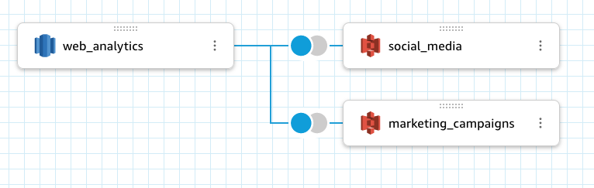

*Image description: The preceding image shows the three data sources as joined tables.*

TASK 1.3: CLEAN UP THE DATASET

Exclude all of the *date_key* fields and the duplicate *date* fields to clean up the dataset. Add a *total_followers* calculated field.

 Hint 1: You can choose all of the fields and exclude them at the same time using the ellipsis icon.

For a walkthrough of how to complete these steps, see [**Exclude fields from a dataset**](https://us-east-1.durian.bkr.team.aws.training/session/eDe9D67izoYGrBxGbwnFM6?locale=en-US&reference=sCm4f4gcixZqMUgXPoUz5y%3A%3A7759f935-0c5f-4c9f-a8d1-ce89471a7323#task1-3-1).

 Hint 2: You need to change the remaining **date** field to a **Date** datatype. The data format is

.

For a walkthrough of how to complete these steps, see [**Change a datatype**](https://us-east-1.durian.bkr.team.aws.training/session/eDe9D67izoYGrBxGbwnFM6?locale=en-US&reference=sCm4f4gcixZqMUgXPoUz5y%3A%3A7759f935-0c5f-4c9f-a8d1-ce89471a7323#task1-3-2).

 Hint 3: Add a calculated field using the **+** button and choosing **Add calculated field**. For **total_followers**, add the **social_1_followers_cumulative** and **social_2_followers_cumulative** fields together.

For a walkthrough of how to complete these steps, see [**Add a calculated field in the dataset editor**](https://us-east-1.durian.bkr.team.aws.training/session/eDe9D67izoYGrBxGbwnFM6?locale=en-US&reference=sCm4f4gcixZqMUgXPoUz5y%3A%3A7759f935-0c5f-4c9f-a8d1-ce89471a7323#task1-3-3).

 Hint 4: The calculation is

.

**Expected output:** After all of the *date_key* fields and duplicate *date* fields are excluded and the new calculated field is added, you have completed this task.

TASK 1.4 GROUP FIELDS IN FIELD FOLDERS

Add the website and social media metrics to field folders.

 Hint 1: If you need a reminder of which fields belong to each dataset, look at **Task 1.1** for a full list of the fields.

 Hint 2: Choose all of the metrics you want to group and add them to a folder at the same time using the ellipsis icon.

For a walkthrough of how to complete these steps, see [**Add fields to a field folder**](https://us-east-1.durian.bkr.team.aws.training/session/eDe9D67izoYGrBxGbwnFM6?locale=en-US&reference=sCm4f4gcixZqMUgXPoUz5y%3A%3A7759f935-0c5f-4c9f-a8d1-ce89471a7323#task1-4).

**Expected output:** After the social media metrics are in one folder and the website metrics are in another, you have completed this task. Your dataset is ready for analysis.

**Consider:** Take a moment to look through the finalized dataset. If you ever needed to add more metrics to this dataset, how would you join a new table? Are there any calculated fields you want to add at the dataset level?

**Task complete:** You have successfully completed **Challenge 1** by joining all three data sources together and editing the dataset. You are ready to create the marketing dashboard.

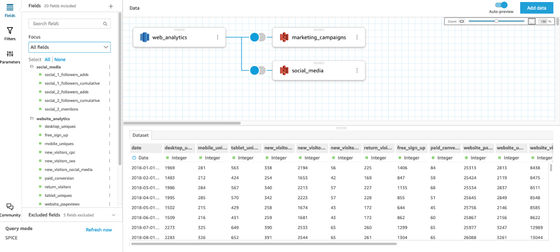

*Image description: The preceding image shows the three data sources are shown with updated data.*

**Challenge 2: Create a dashboard**

The data sources are joined together into one dataset. The dashboard is ready to be created and you want to start with the high-level marketing metrics and KPIs, while also adding a forecast and an automated insight to explore the marketing results.

To complete this task, you will complete the following subtasks:

* Add dashboard visualizations.
* Add a forecast and an automated insight.
* Format charts.
* Create filters.
* Organize the dashboard.

This challenge will take approximately *45* minutes to complete.

TASK 2.1: ADD DASHBOARD VISUALIZATIONS

The marketing team asked for six important visualizations:

* A **Stacked bar combo chart** showing bars with the three **new_visitors_** fields, lines with the **paid_conversion** and **free_sign_up** fields, over **date** aggregated by month.
* A **KPI** with the total number of **website_visits**
* A **KPI** with the total number of **social_2_mentions**
* A **KPI** with the maximum number of **total_followers**
* A **donut chart** with all of the **events**, excluding empty rows
* A **bar chart** with the number of **paid_conversion** visitors by **events**, excluding empty rows

**Note:** Take time to slowly build up the dashboard. This task is the most important and you have time to focus on making well-designed visualizations. If you get stuck, the image of the the six visualizations is included after the hints.

 Hint 1: Create a new analysis based on the dataset you just finished editing.

 Hint 2: Start with the stacked bar combo chart. Time fields usually go in the **X axis** section of the **Visuals** pane. For this visualization, there should be three fields in the **Bars** section and two fields in the **Lines** section.

For a walkthrough of how to complete these steps, see [**Add a visualization to the dashboard workspace**](https://us-east-1.durian.bkr.team.aws.training/session/eDe9D67izoYGrBxGbwnFM6?locale=en-US&reference=sCm4f4gcixZqMUgXPoUz5y%3A%3A7759f935-0c5f-4c9f-a8d1-ce89471a7323#task2-1).

 Hint 3: You can quickly filter out the empty slice of the donut chart by selecting the slice and choosing **Exclude empty**.

 Hint 4: If you want to edit a visualization title, double-click on the title to open the **Edit title** menu.

 Hint 5: If you add a field to a visualization by mistake, choose the field in the **Visuals** pane and choose **Remove**.

 Hint 6: If you need advanced visualization formatting options, choose the visualization and choose the **Format visual** pencil icon to open the **Properties** menu.

**Expected output:** After you have added all six visualizations, you have completed this task.

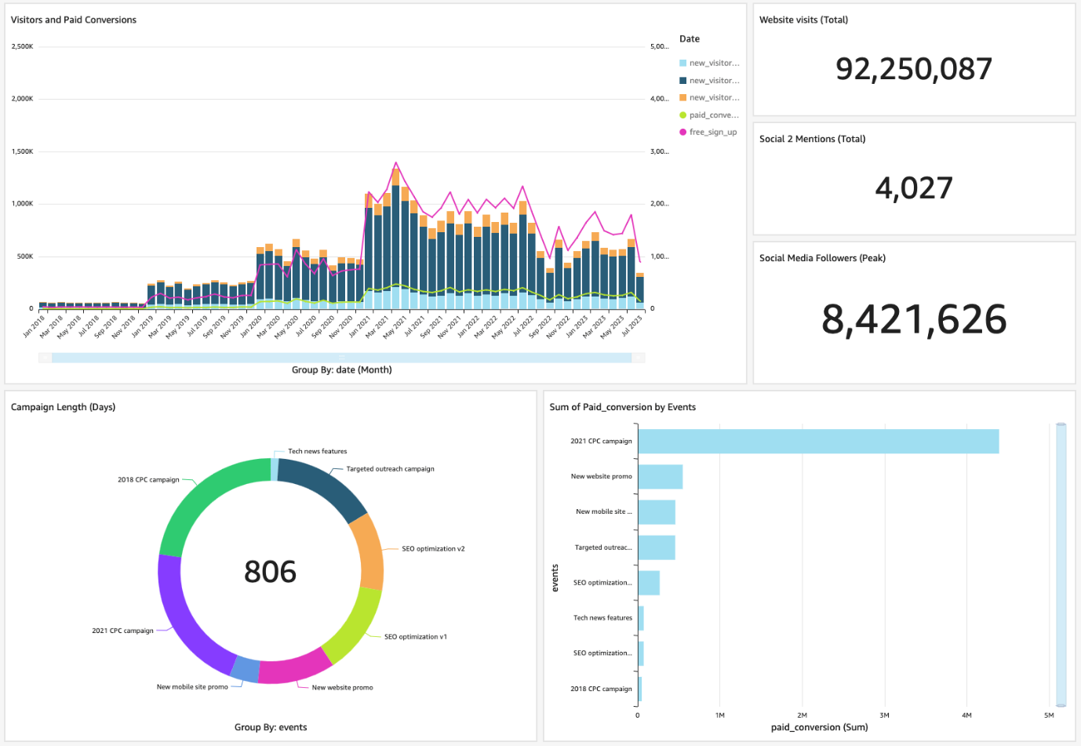

*Image description: The preceding image shows the dashboard.*

TASK 2.2: ADD A FORECAST AND AN AUTOMATED INSIGHT

Create a new line chart visualization that shows visitors by device over time, aggregated by month, and add a forecast to the visualization. Then, create a paid conversion period-over-period automated insight.

 Hint 1: There are four fields to add for the visitors by device over time visualization: **date**, **mobile_uniques**, **tablet_uniques**, and **desktop_uniques**.

 Hint 2: You can add a forecast using the visualization menu by choosing the **Menu options** ellipsis icon and choosing **Add forecast**.

For a walkthrough of how to complete these steps, see [**Add a forecast to a visualization**](https://us-east-1.durian.bkr.team.aws.training/session/eDe9D67izoYGrBxGbwnFM6?locale=en-US&reference=sCm4f4gcixZqMUgXPoUz5y%3A%3A7759f935-0c5f-4c9f-a8d1-ce89471a7323#task2-2-1).

 Hint 3: To make an insight, choose **Insert** and choose **Add insight**. Use a **Period over period** insight type and use the **paid_conversion** and **date** fields.

 Hint 4: You can improve your insight by changing the aggregation in the **Value** pane from **Aggregate: Day** to **Aggregate: Month** or **Aggregate: Year**.

For a walkthrough of how to complete these steps, see [**Add an insight to the dashboard workspace**](https://us-east-1.durian.bkr.team.aws.training/session/eDe9D67izoYGrBxGbwnFM6?locale=en-US&reference=sCm4f4gcixZqMUgXPoUz5y%3A%3A7759f935-0c5f-4c9f-a8d1-ce89471a7323#task2-2-2).

**Expected output:** After you have added a new line chart with a visitors by device forecast and a paid conversion period over period automated insight, you have completed this task.

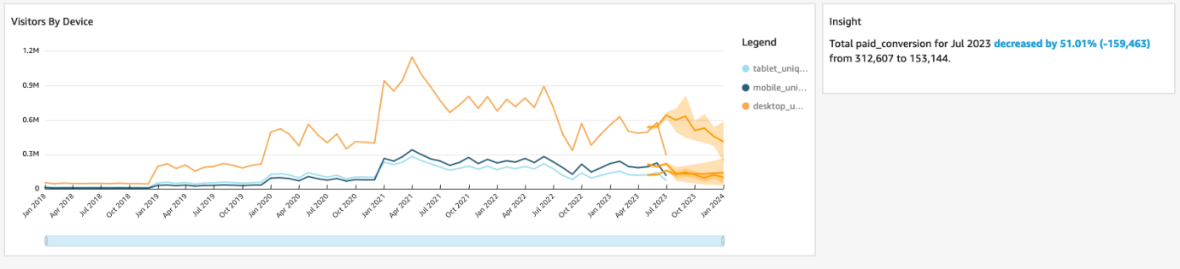

*Image description: The preceding image shows the forecast and period over period visualization.*

TASK 2.3: FORMAT CHARTS

Edit the **Visitors by Device** forecast period to six months forward and three months back. Remove the legend from the **Campaign Length (Days)** donut chart.

 Hint 1: You can edit the forecast by choosing the **Menu options** ellipsis icon on the visualization menu and choosing **Edit forecast**.

 Hint 2: You can hide the legend by choosing the **Menu options** ellipsis icon on the visualization menu and choosing **Hide legend**.

**Expected output:** After you have edited the forecast and removed the legend, you have completed this task.

TASK 2.4: CREATE FILTERS

Add filters for *date*, *events*, *social_1_follower_adds*, and *social_2_follower_adds*.

**Note:** The date and event filters help your marketing team investigate different campaigns and seasonal trends. The follower adds filters help the team investigate which variables characterize the high and low trends in social media follower growth.

 Hint 1: Select a visual to add a filter.

 Hint 2: Choose the ellipsis icon next to each field in the **Fields list** and choose **Add filter for this field**.

 Hint 3: Configure all of the filters to apply to **All applicable visuals**. When you are ready to add the filters to the dashboard, in the **Filters** pane, choose the ellipsis icon next to the filter and choose **Add to sheet**.

**Note:** The dataset has dates ranging from 2017/12/31 to 2022/01/01.

 Hint 4: For the **social_1_follower_adds** and **social_2_follower_adds** filters, choose a range of

 to

 with a step of

.

For a walkthrough of how to complete these steps, see [**Create a filter and add it to a dashboard**](https://us-east-1.durian.bkr.team.aws.training/session/eDe9D67izoYGrBxGbwnFM6?locale=en-US&reference=sCm4f4gcixZqMUgXPoUz5y%3A%3A7759f935-0c5f-4c9f-a8d1-ce89471a7323#task2-4).

**Expected output:** After you have added all four filters, you have completed **Task 2.4**.

TASK 2.5: ORGANIZE THE DASHBOARD

The marketing team wants the dashboard organized in the following order:

* Put the filters across the top row.
* Put the KPIs and the **Paid Conversion Insight** to the right of the filters and line chart visualizations.
* Put the **Visitors and Paid Conversion** and **Visitor by Device** visualizations below the row of filters.
* Put the **Campaign Length (Days)** visualization below the line chart visualizations on the left side of the dashboard.
* Put the **Paid Conversions by Event** bar chart visualization below the line charts and KPIs on the right side of the dashboard.

 Hint 1: You can resize the visualization by selecting and dragging any of the white squares at the corners or edges of the visualization.

**Expected output:** After you have reorganized the dashboard, you have completed this task.

**Consider:** Take a moment to adjust the filters and investigate factors that impact the visitors and paid conversions. Do you like how this dashboard is set up? Do you want to make any changes?

**Task complete:** You have successfully completed **Challenge 2** by creating a marketing dashboard and you are ready to enhance the dashboard and add interactivity.

**Challenge 3: Enhance the dashboard and add interactivity**

You want to enhance the dashboard by adjusting the theme to match the marketing team’s branding.

You also want to add interactivity to the dashboard to improve the marketing team’s experience and increase the number of tools that they can use to dive into the data.

To complete this task, you will complete the following subtasks:

* Apply changes to a theme.
* Create a filter action.
* Implement cross-sheet functionality.

This challenge will take approximately *30* minutes to complete.

TASK 3.1: APPLY CHANGES TO A THEME

Create a new theme. Change the default text font to **Inter** and edit the **Accent** color to

. Add two new data colors of

 and

, and make them the first two colors in the theme.

 Hint 1: To edit a theme, in the navigation pane at the top of the page, choose **Edit** and then choose **Themes**.

 Hint 2: To create a new theme, next to the applied theme, choose the ellipsis icon and choose **Save as**. Configure all of the options according to the theme requests from the marketing team.

For a walkthrough of how to complete these steps, see [**Add a new data color to a theme**](https://us-east-1.durian.bkr.team.aws.training/session/eDe9D67izoYGrBxGbwnFM6?locale=en-US&reference=sCm4f4gcixZqMUgXPoUz5y%3A%3A7759f935-0c5f-4c9f-a8d1-ce89471a7323#task3-1).

**Expected output:** After you have created a new theme, edited the theme configurations, and applied the theme to your analysis, you have completed this task.

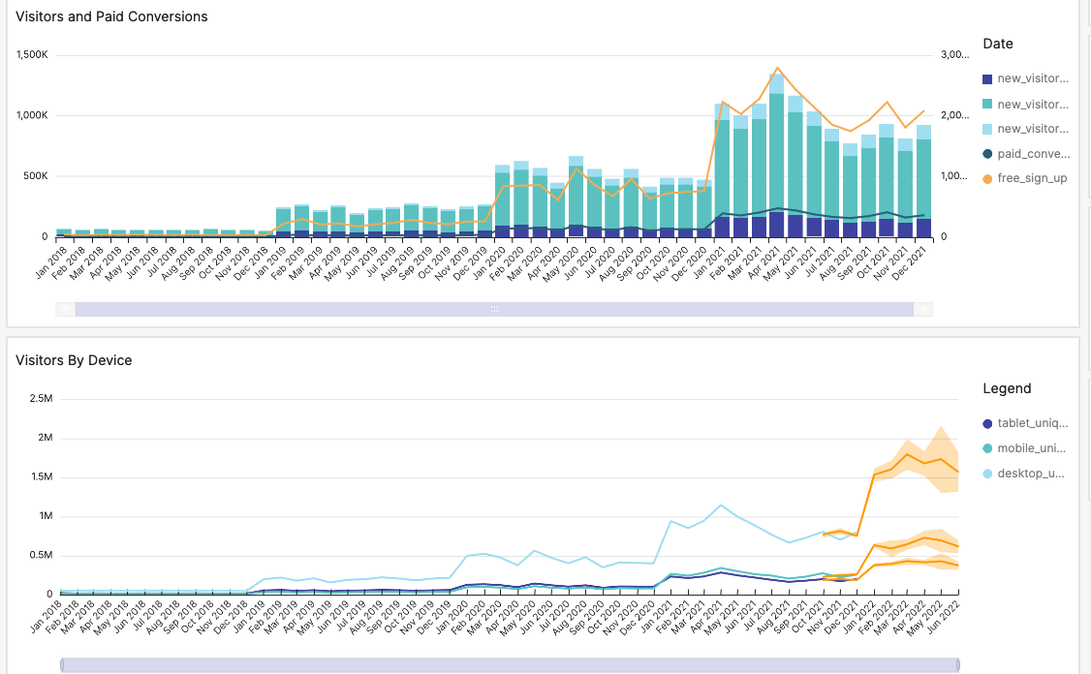

*Image description: The preceding image shows visualizations with the edited theme applied.*

TASK 3.2: CREATE A FILTER ACTION

The marketing team wants to be able to select a month on the **Visitors and Paid Conversions** visualization and have the other visualizations filter based on the selection.

Create a filter action that filters the other visuals based on the reader’s selection.

 Hint 1: Create a filter action using the **Actions** pane.

 Hint 2: After selecting the **Visitors and Paid Conversions** visualization, choose **Filter same-sheet visuals** to start adding the filter action.

For a walkthrough of how to complete these steps, see [**Add a filter action to a visualization**](https://us-east-1.durian.bkr.team.aws.training/session/eDe9D67izoYGrBxGbwnFM6?locale=en-US&reference=sCm4f4gcixZqMUgXPoUz5y%3A%3A7759f935-0c5f-4c9f-a8d1-ce89471a7323#task3-2).

**Expected output:** After you have added a filter action to the **Visitors and Paid Conversions** visualization, you have completed this task.

TASK 3.3: IMPLEMENT CROSS-SHEET FUNCTIONALITY

The marketing team wants to be able to dig into each campaign individually. They want an *Event Details* table that filters based on a selection on the *Campaign Length* donut chart.

Implement cross-sheet functionality that navigates a reader to a filtered table visualization on the *Details* tab based on a selection in the donut chart visualization on the *Summary* tab.

 Hint 1: Create a **Details** tab first. Then, add a new **Pivot table** visualization.

 Hint 2: For the **Event Details** table, in the **Visuals** pane, in the **Rows** section, add **events**. In the **Values** section, add **free_sign_up**, **paid_conversion**, **return_visitors**, **website_pageviews**, **website_unique_visits**, **social_1_followers_adds**, **social_2_followers_adds**, and **social_2_mentions**.

 Hint 3: To add cross-sheet functionality, start by adding an **Event** parameter on the destination visualization.

**Note:** The source visualization for this challenge is the **Campaign Length** donut chart on the **Summary** tab, and the destination visualization is the **Event Details** table you just created on the **Details** tab.

For a walkthrough of how to complete these steps, see [**Create a parameter**](https://us-east-1.durian.bkr.team.aws.training/session/eDe9D67izoYGrBxGbwnFM6?locale=en-US&reference=sCm4f4gcixZqMUgXPoUz5y%3A%3A7759f935-0c5f-4c9f-a8d1-ce89471a7323#task3-3-1).

 Hint 4: To continue implementing cross-sheet functionality, create a navigation action on the source visualization.

For a walkthrough of how to complete these steps, see [**Create a navigation action**](https://us-east-1.durian.bkr.team.aws.training/session/eDe9D67izoYGrBxGbwnFM6?locale=en-US&reference=sCm4f4gcixZqMUgXPoUz5y%3A%3A7759f935-0c5f-4c9f-a8d1-ce89471a7323#task3-3-2).

 Hint 5: To finish implementing cross-sheet functionality, create a filter based on the parameter in the destination visualization.

For a walkthrough of how to complete these steps, see [**Create a filter based on a parameter**](https://us-east-1.durian.bkr.team.aws.training/session/eDe9D67izoYGrBxGbwnFM6?locale=en-US&reference=sCm4f4gcixZqMUgXPoUz5y%3A%3A7759f935-0c5f-4c9f-a8d1-ce89471a7323#task3-3-3).

**Expected output:** After you have created an *Event Details* pivot table visualization and added cross-sheet functionality, you have completed this task.

**Consider:** Take a moment to test out the cross-sheet functionality. Are there any more fields you want to include in the *Event Details* table?

**Task complete:** You have successfully completed **Challenge 3** by creating a custom theme, creating a filter action, and adding cross-sheet functionality. You are ready to add calculations to the dashboard.

**Challenge 4: Perform advanced data calculations**

A few additive and non-additive calculations are not included in the original data sources. The marketing team asked you to create these fields and include them in a few important visualizations.

To complete this task, you will complete the following subtasks:

* Create an additive measure.
* Create a non-additive measure.
* Calculate a level-aware aggregation for a KPI.

This challenge will take approximately *15* minutes to complete.

TASK 4.1: CREATE AN ADDITIVE MEASURE

Add all of the *new_visitors_* fields together to create a *new_visitors* field that the marketing team can use to track the aggregate new visitor growth over time. Then, create a chart that shows the total number of new visitors per year.

 Hint 1: Create a calculated field using the **Insert** button.

 Hint 2: Add the **new_visitors_cpc**, **new_visitors_seo**, and **new_visitors_social_media** fields together.

For a walkthrough of how to complete these steps, see [**Create a calculated field**](https://us-east-1.durian.bkr.team.aws.training/session/eDe9D67izoYGrBxGbwnFM6?locale=en-US&reference=sCm4f4gcixZqMUgXPoUz5y%3A%3A7759f935-0c5f-4c9f-a8d1-ce89471a7323#task4-1).

 Hint 3: Create a line chart or bar chart and add the **date** and **new_visitors** fields to complete the task.

**Expected output:** After you have created the visualization with the new additive measure, you have completed this task.

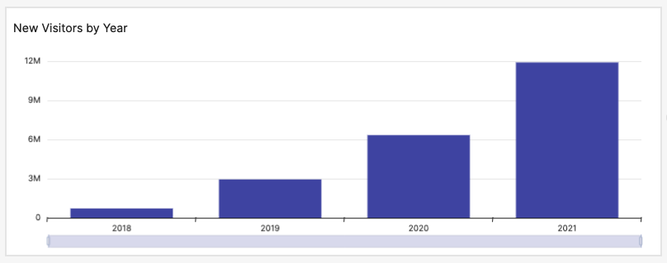

*Image description: The preceding image shows a bar chart with the new additive measure.*

TASK 4.2: CREATE A NON-ADDITIVE MEASURE

Create a non-additive measure that calculates the average number of page views it takes to convert a visitor from a free subscription to a paid subscription. Then, create a chart that shows the number of page views it took for each campaign type to convert a free subscription to a paid subscription.

 Hint 1: Create a new calculation using the **paid_conversion** and **website_pageviews** fields.

 Hint 2: For non-additive measures, use

 on each field before dividing.

 Hint 3: The calculation is

.

 Hint 4: Create a bar chart similar to the **Paid Conversions by Event** bar chart, replacing **paid_conversion** with your new field.

**Expected output:** After you have created the bar chart visualization with the new non-additive measure, you have completed this task.

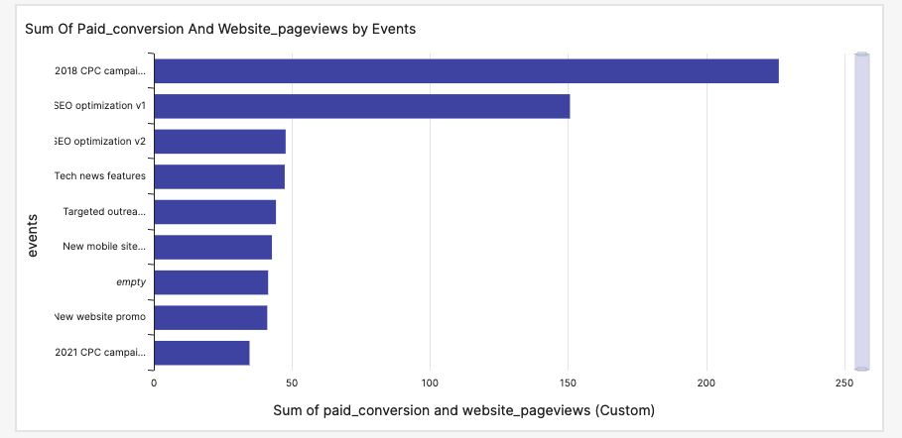

*Image description: The preceding image shows a bar chart with the non-additive measure.*

TASK 4.3: CALCULATE A LEVEL-AWARE AGGREGATION FOR A KPI

Create a new aggregation for the total number of Social 2 mentions that AnyCompany Software has received that is calculated before filtering. Then, replace the value in the *Social 2 Mentions (Total)* KPI visualization with your new level-aware aggregation.

 Hint 1: Use the

 field and the

 keyword in the calculation.

 Hint 2: The calculation is

.

**Expected output:** After you have replaced the field in the KPI visualization, you have completed this task.

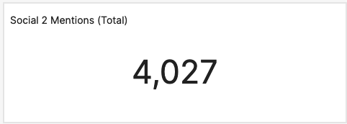

*Image description: The preceding image shows the new social media mentions KPI.*

**Consider:** Take a moment to test how the visualizations interact with the filters. Does the updated KPI visualization change when you adjust the filters? What other KPIs could use similar level-aware aggregations?

**Task complete:** You have successfully completed **Challenge 4** by creating additive and non-additive measures and replacing a KPI value with a level-aware aggregation. You are ready to integrate more machine learning tools into the marketing dashboard.

**Challenge 5: Integrate machine learning tools into the dashboard**

The marketing team came back with feedback about the narratives and machine learning predictions. They want a custom forecast and would like to see if there have been any anomalies in website page views.

To complete this task, you will complete the following subtasks:

* Create and edit a forecast insight narrative.
* Conduct anomaly detection.

This challenge will take approximately *15* minutes to complete.

TASK 5.1: CREATE AND EDIT A FORECAST INSIGHT NARRATIVE

Create a *Sign Up and Conversion Forecast* insight with the *paid_conversion* and *date* (Month) fields that forecasts forward six months.

 Hint 1: Create an insight using the **Forecast** option, and add the **paid_conversion** and **date** fields.

 Hint 2: You need to edit the **ForecastInsight** computation to include a **Periods forward** of

 instead of

. In the narrative editor, choose the **Computations** menu to expand it and use the pencil icon to edit the computation.

For a walkthrough of how to complete these steps, see [**Edit a narrative**](https://us-east-1.durian.bkr.team.aws.training/session/eDe9D67izoYGrBxGbwnFM6?locale=en-US&reference=sCm4f4gcixZqMUgXPoUz5y%3A%3A7759f935-0c5f-4c9f-a8d1-ce89471a7323#task5-2).

**Consider:** Take a moment to read the *Preview* paragraph. Is there a way to clarify that this forecast has a six-month view?

 Hint 3: If you get stuck, the final narrative is the following:

Total ForecastInsight.metricField.name in six months is forecasted to be ForecastInsight.metricValue.formattedValue for ForecastInsight.timeValue.formattedValue

**Note:** You cannot copy and paste this block into the narrative editor, but you can use it as a reference.

**Expected output:** After you have created and edited the narrative, you have completed this task.

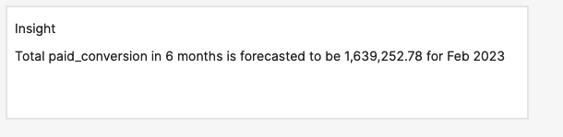

*Image description: The preceding image shows the paid conversion forecast visualization with the applied edits.*

TASK 5.2: CONDUCT ANOMALY DETECTION

The marketing team wants to see if there are any anomalies you can find in the data. Specifically, they want to see if there were any unusual spikes in website page views.

Conduct anomaly detection to see if there are any outliers in the *website_pageviews* field.

 Hint 1: Insert a new **Anomaly detection** insight and add the **date** and **website_pageviews** fields.

 Hint 2: For this anomaly detection, you can leave the **date** aggregation as **Day**.

**Expected output:** After you have created and run the anomaly detection, you have completed this task.

**Consider:** Are there any other anomalies you want to explore? Are there any fields you can add that could be helpful to explore this anomaly further?

**Task complete:** You have successfully completed **Challenge 5** by creating and editing a forecast insight narrative and conducting anomaly detection.

**Conclusion**

**Task complete:** You have completed the marketing dashboard. The team is excited to dig into the event insights and improve their visitor reach and conversion using data-driven decision making.

You have successfully done the following:

* Joined three or more data sources together into one dataset
* Created an analysis from a new dataset
* Implemented interactivity and customize formatting
* Performed advanced data calculations
* Integrated machine learning at multiple levels

**End lab**

Follow these steps to close out the console and end your lab.

1. At the upper-right corner of the QuickSight console, choose the user icon and then choose **Sign out**.
2. On this screen, choose **End lab** and then confirm that you want to end your lab.

**Appendix**

CONNECT TO AN AMAZON REDSHIFT DATABASE

To connect to an Amazon Redshift database, use the following steps:

1. In the left navigation pane, choose **Datasets**.
2. Choose **New dataset**.
3. From the list of sources, choose **Redshift (Manual connect)**.
4. For **Data source name**, enter something descriptive such as

 as the name for your new data source.

1. For **Connection type**, leave the default option.
2. For **Database server**, enter the name of your database server. For this lab, the **RedshiftDatabaseServer** value is listed to the left of these instructions.
3. For **Port**, enter

.

1. For **Database name**, enter the name of your database. For this lab, the **RedshiftDatabaseName** value is listed to the left of these instructions.
2. For **Username**, enter your Amazon Redshift username. For this lab, the **RedshiftUsername** value is listed to the left of these instructions.
3. For **Password**, enter your Amazon Redshift password. For this lab, the **RedshiftPassword** value is listed to the left of these instructions.

**Note:** You can choose **Validate connection** to confirm that the connection works before creating the data source.

When you are done, the menu might look like this:

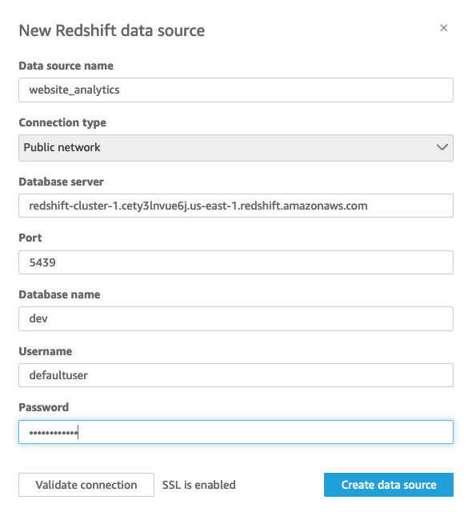

*Image description: The preceding image shows the interface for a manual Redshift data source with values applied.*

1. Choose **Create data source**.
2. Choose your table from the list, and choose **Select**.
3. Choose **Edit/Preview data**.
4. Choose **SAVE & PUBLISH**.
5. Choose the QuickSight icon at the top of the page to return to the QuickSight menu.

**Task complete:** You have successfully connected to an Amazon Redshift database.

To continue this lab, return to [Task 1.1](https://us-east-1.durian.bkr.team.aws.training/session/eDe9D67izoYGrBxGbwnFM6?locale=en-US&reference=sCm4f4gcixZqMUgXPoUz5y%3A%3A7759f935-0c5f-4c9f-a8d1-ce89471a7323#task1-1-1-continue).

CONNECT TO AN AMAZON S3 OBJECT USING A URI AND A MANIFEST FILE

To connect to an Amazon S3 object using a **URI**, use the following steps:

1. In the left navigation pane, choose **Datasets**.
2. Choose **New dataset**.
3. From the list of sources, choose **S3**.
4. For **Data source name**, enter something descriptive such as

 or

 as the name for your new data source, depending on which file you are uploading.

1. Save the [sample_manifest_uri](https://us-west-2-tcprod.s3.amazonaws.com/courses/ILT-DD-300-DAQSAU/v1.4.1.prod-74c9bead/lab-challenge/scripts/sample_manifest_uri.json) file to your local machine.
2. Open the file using a text editor.
3. In the editor, replace **BUCKET_NAME** with the name of your bucket. For this lab, the **BucketName** value is listed to the left of these instructions.
4. In the editor, replace **FILE_NAME** with the name of your object. For this lab, the **SocialTable** value is listed to the left of these instructions and is the name of the file with the social media table. Also listed to the left is **MarketingTable**, which is the name of the file with the marketing table.
5. Save and close the file on your local machine.
6. For **Upload a manifest file**, choose **Upload**.
7. To open the file explorer, choose **Upload a JSON manifest file**.
8. Choose the **sample_manifest_uri.json** file you edited on your local machine, and choose **Open**.
9. After the preview has loaded, choose **Connect**.
10. Choose **Edit/Preview data**.
11. Choose **SAVE & PUBLISH**.
12. Choose the QuickSight icon at the top of the page to return to the QuickSight menu.

**Task complete:** You have successfully connected to an Amazon S3 object using a **URI**.

To continue this lab, return to [Task 1.1](https://us-east-1.durian.bkr.team.aws.training/session/eDe9D67izoYGrBxGbwnFM6?locale=en-US&reference=sCm4f4gcixZqMUgXPoUz5y%3A%3A7759f935-0c5f-4c9f-a8d1-ce89471a7323#task1-1-2-continue).

CONNECT TWO OR MORE TABLES TOGETHER

To join two or more tables together, use the following steps:

1. In the left navigation pane, choose **Datasets**.
2. Choose a dataset from your dataset list that you want to join data to.
3. Choose **Edit dataset**.
4. Choose **Add data**.
5. From the dropdown list, choose **Data source**.
6. Choose a data source from the data source list that you want to join, and choose **Select**.
7. In the **Table** section, choose the table you want to add, and choose **Select**.

Both tables appear in the data preparation page.

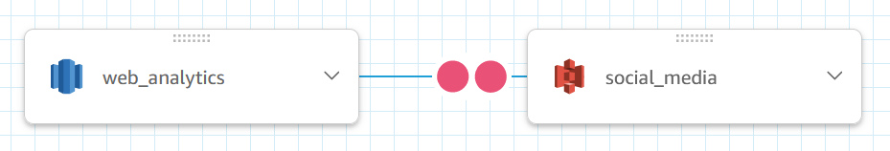

*Image description: The preceding image shows the tables as connected in the data preparation page.*

You can repeat these steps to add more tables to the workspace.

1. To configure the join, choose the two red dots between the data sources.
2. Choose a common key in both dropdown lists and choose your join type. For this lab, you can join the tables on the **date_key** field, and use any of the join types because the data in all of the tables is for the same date range.
3. To finalize the join, choose **Apply**.

You can repeat these steps to join more tables in the workspace.

1. When you are done joining tables, choose **SAVE & PUBLISH**.

**Task complete:** You have successfully joined two or more tables together.

To continue this lab, return to [Task 1.2](https://us-east-1.durian.bkr.team.aws.training/session/eDe9D67izoYGrBxGbwnFM6?locale=en-US&reference=sCm4f4gcixZqMUgXPoUz5y%3A%3A7759f935-0c5f-4c9f-a8d1-ce89471a7323#task1-2-continue).

EXCLUDE FIELDS FROM A DATASET

To exclude fields from a dataset, use the following steps:

1. In the **Fields** menu to the left of the dataset workspace, choose the fields you want to exclude; in this case, it’s the duplicate **date** fields and all of the **date_key** fields.
2. Choose the ellipsis icon next to any of the fields you selected, and choose **Exclude fields**.

The fields appear in the **Excluded fields** list.

**Task complete:** You have successfully excluded fields from a dataset.

To continue this lab, return to [Task 1.3](https://us-east-1.durian.bkr.team.aws.training/session/eDe9D67izoYGrBxGbwnFM6?locale=en-US&reference=sCm4f4gcixZqMUgXPoUz5y%3A%3A7759f935-0c5f-4c9f-a8d1-ce89471a7323#task1-3-1-continue).

CHANGE A DATATYPE

To change a datatype in the dataset editor, use the following steps:

1. In the preview table under the dataset workspace, choose the datatype that is currently assigned to the field you want to edit.
2. From the list, choose the new datatype.
3. If the datatype is a **Date**, you need to enter the date format. In this lab, the date format is

.

1. Choose **Update**.

**Task complete:** You have successfully changed a datatype for a field.

To continue this lab, return to [Task 1.3](https://us-east-1.durian.bkr.team.aws.training/session/eDe9D67izoYGrBxGbwnFM6?locale=en-US&reference=sCm4f4gcixZqMUgXPoUz5y%3A%3A7759f935-0c5f-4c9f-a8d1-ce89471a7323#task1-3-2-continue).

ADD A CALCULATED FIELD IN THE DATASET EDITOR

To add a calculated field in the dataset editor, use the following steps:

1. Choose the plus sign **+** and choose **Add calculated field**.
2. For **Add name**, enter the name of your new field, such as

.

1. In the calculation workspace, enter your calculation. For this task, it adds **social_1_followers_cumulative** and **social_2_followers_cumulative** together.

**Note:** You can use *Fields* and *Functions* in a calculation. Choose the menu pane for the corresponding options that you want to expand. You can add a field by selecting (double-click) it.

1. Choose **Save**.

**Task complete:** You have successfully added a calculated field in the dataset editor.

To continue this lab, return to [Task 1.3](https://us-east-1.durian.bkr.team.aws.training/session/eDe9D67izoYGrBxGbwnFM6?locale=en-US&reference=sCm4f4gcixZqMUgXPoUz5y%3A%3A7759f935-0c5f-4c9f-a8d1-ce89471a7323#task1-3-3-continue).

ADD FIELDS TO A FIELD FOLDER

To add fields to a field folder, use the following steps:

1. In the **Fields** pane, choose the fields you want to add to a folder.
2. Choose the ellipsis icon next to any of the fields that you selected, and choose **Add to folder**.
3. In the **Create a new folder** section, enter a name for your folder.
4. Choose **Apply**.

**Task complete:** You have successfully added fields to a field folder.

To continue this lab, return to [Task 1.4](https://us-east-1.durian.bkr.team.aws.training/session/eDe9D67izoYGrBxGbwnFM6?locale=en-US&reference=sCm4f4gcixZqMUgXPoUz5y%3A%3A7759f935-0c5f-4c9f-a8d1-ce89471a7323#task1-4-continue).

ADD A VISUALIZATION TO THE DASHBOARD WORKSPACE

To add a visualization to the dashboard workspace, use the following steps:

1. In the top menu bar, choose **Insert**.
2. Choose **Add visual**.
3. In the **Visuals** pane, choose the visualization type that you want.
4. In the **Fields list** pane, choose the fields that you want to use.
5. In the **Visuals** pane, move the fields around to the correct sections if needed.
6. If you want to change the aggregation of a date, in the **Visuals** pane, choose the ellipsis icon next to the date field.
7. Hover over **Aggregate: Day** and change the aggregation to the aggregation period you need.

**Task complete:** You have successfully created and customized a visualization.

To continue this lab, return to [Task 2.1](https://us-east-1.durian.bkr.team.aws.training/session/eDe9D67izoYGrBxGbwnFM6?locale=en-US&reference=sCm4f4gcixZqMUgXPoUz5y%3A%3A7759f935-0c5f-4c9f-a8d1-ce89471a7323#task2-1-continue).

ADD A FORECAST TO A VISUALIZATION

To add a forecast to a visualization, use the following steps:

1. Select the visualization that you want to add the forecast to.

**Note:** The visualization needs to be compatible with forecasts. Line charts are one visual type that is compatible.

1. In the visualization menu on the right of your sales visualization, choose the **Menu options** ellipsis icon, and then choose **Add forecast**.

**Task complete:** You have successfully added a forecast to a visualization.

To continue this lab, return to [Task 2.2](https://us-east-1.durian.bkr.team.aws.training/session/eDe9D67izoYGrBxGbwnFM6?locale=en-US&reference=sCm4f4gcixZqMUgXPoUz5y%3A%3A7759f935-0c5f-4c9f-a8d1-ce89471a7323#task2-2-1-continue).

ADD AN INSIGHT TO THE DASHBOARD WORKSPACE

To add an insight to the dashboard workspace, use the following steps:

1. In the top menu bar, choose **Insert**.
2. Choose **Add insight**.
3. In the **Computation** menu, from the dropdown list, choose your **Computation type**.
4. Choose **Select**.
5. In the **Fields list** pane, choose the fields that you want to use.
6. If you want to change the aggregation of a date, in the **Visuals** pane, choose the ellipsis icon next to the date field.
7. Hover over **Aggregate: Day** and change the aggregation to the aggregation period you want.

**Task complete:** You have successfully added an insight to the dashboard workspace.

To continue this lab, return to [Task 2.2](https://us-east-1.durian.bkr.team.aws.training/session/eDe9D67izoYGrBxGbwnFM6?locale=en-US&reference=sCm4f4gcixZqMUgXPoUz5y%3A%3A7759f935-0c5f-4c9f-a8d1-ce89471a7323#task2-2-2-continue).

CREATE A FILTER AND ADD IT TO A DASHBOARD

To create a filter and add it to a dashboard, use the following steps:

1. Choose any visualization on the dashboard.
2. In the **Fields list** pane, choose the ellipsis next to the field you want to add as a filter and choose **Add filter for this field**.
3. To expand the filter options, in the **Filter** pane, choose the name of the field that you just added.
4. To filter all of the visualizations on your dashboard at the same time, under **Edit filter**, choose **Only this visual**, and then choose **All applicable visuals**.
5. In the **Filter type** section, make changes to the settings if needed.
6. Choose the ellipsis icon next to the filter name and choose **Add to sheet**.
7. Choose **Apply**.

**Task complete:** You have successfully created a filter and added it to the dashboard.

To continue this lab, return to [Task 2.4](https://us-east-1.durian.bkr.team.aws.training/session/eDe9D67izoYGrBxGbwnFM6?locale=en-US&reference=sCm4f4gcixZqMUgXPoUz5y%3A%3A7759f935-0c5f-4c9f-a8d1-ce89471a7323#task2-4-continue).

ADD A NEW DATA COLOR TO A THEME

To add a new data color to a theme, use the following steps:

1. In the navigation pane at the left of the page, choose **Data**.
2. In the **Data colors** section, choose the grey plus sign **+** icon.
3. Choose **Custom color**.

**Note:** If you have recently used the custom color option, the color might appear under **Recent custom colors**.

1. In the **HEX** section, clear the current value and enter your color’s HEX value.
2. Choose **Apply**.
3. At the end of the **Data colors** list, choose the new color and drag it to the front of the color list.

**Task complete:** You have successfully added a new data color to a theme.

To continue this lab, return to [Task 3.1](https://us-east-1.durian.bkr.team.aws.training/session/eDe9D67izoYGrBxGbwnFM6?locale=en-US&reference=sCm4f4gcixZqMUgXPoUz5y%3A%3A7759f935-0c5f-4c9f-a8d1-ce89471a7323#task3-1-continue).

ADD A FILTER ACTION TO A VISUALIZATION

To add a filter action to a visualization, use the following steps:

1. Choose the visualization that you want to add a filter action to.
2. In the visualization menu at the right of the visual, choose the **Menu options** ellipsis icon and choose **Actions**.
3. In the **Actions** pane, choose **Filter same-sheet visuals**.
4. Next to **Action 1**, choose the arrow and then choose **Edit**.
5. In the **Target visuals** pane, choose **Select visuals**.
6. Clear the visuals that break when selections are made in the **Visitors and Paid Conversions** visualization. For this lab, you can clear **Paid Conversion Insight** and **Visitors by Device**.
7. Choose **Save**.

**Task complete:** You have successfully added a filter action to a visualization.

To continue this lab, return to [Task 3.2](https://us-east-1.durian.bkr.team.aws.training/session/eDe9D67izoYGrBxGbwnFM6?locale=en-US&reference=sCm4f4gcixZqMUgXPoUz5y%3A%3A7759f935-0c5f-4c9f-a8d1-ce89471a7323#task3-2-continue).

CREATE A PARAMETER

To create a parameter, use the following steps:

1. In the dashboard workspace, choose the visualization that you want to add a parameter to. For this lab, choose the **Event Details** table visualization.
2. In the navigation pane at the top of the page, choose **Parameters**.
3. In the **Parameters** pane, choose **+ ADD**.
4. For **Name**, enter a value. For this lab, enter

.

1. Choose **Create**.
2. Choose the **Custom actions** icon.
3. In the navigation pane at the top of the page, choose **Parameters**.
4. Next to the parameter you just added, choose the ellipsis icon.
5. To add a parameter control menu to your dashboard, choose **Add control**.
6. Enter a value for **Name**. For this lab, enter

.

1. Choose **+ ADD**.

**Task complete:** You have successfully created a parameter.

To continue this lab, return to [Task 3.3](https://us-east-1.durian.bkr.team.aws.training/session/eDe9D67izoYGrBxGbwnFM6?locale=en-US&reference=sCm4f4gcixZqMUgXPoUz5y%3A%3A7759f935-0c5f-4c9f-a8d1-ce89471a7323#task3-3-1-continue).

CREATE A NAVIGATION ACTION

To create a navigation action, use the following steps:

1. Choose your source visualization. For this lab, it is the **Campaign Length** donut chart on the **Summary** tab.
2. In the visualization menu at the right of the donut chart, choose the ellipsis icon and choose **Actions**.
3. In the **Actions** pane, choose **+ ADD**.
4. For **Action name**, enter a name. For this lab, enter

.

1. For **Activation**, if you want to add your action as a menu option when you right-click a slice, choose **Menu option**, or if you want to navigate to the **Details** tab when you choose an **events** slice, choose **Select**.
2. For **Action type**, choose **Navigation action**.
3. For **Target sheet**, choose your destination tab. For this lab, choose **Details**.
4. In the **Parameters** pane, choose the plus sign **+** icon.
5. For **Parameter**, choose the parameter that you created earlier.
6. For **Set parameter value**, choose the field that you want to filter for. For this lab, choose **Field: events**.
7. Choose **+ ADD**.
8. Choose **Save**.

**Task complete:** You have successfully created a navigation action.

To continue this lab, return to [Task 3.3](https://us-east-1.durian.bkr.team.aws.training/session/eDe9D67izoYGrBxGbwnFM6?locale=en-US&reference=sCm4f4gcixZqMUgXPoUz5y%3A%3A7759f935-0c5f-4c9f-a8d1-ce89471a7323#task3-3-2-continue).

CREATE A FILTER BASED ON A PARAMETER

To create a filter based on a parameter, use the following steps:

1. Choose your destination visualization. For this lab, it is the **Event Details** table on the **Details** tab.
2. In the navigation pane at the top of the page, choose **Filter**.
3. In the **Filters** pane, choose **+ ADD**.
4. From the list, choose the field that you want to filter by. For this lab, choose **events**.
5. To expand the filter options, choose the filter that you just created. For this lab, choose the **events** filter with the **Include - all** subtitle.
6. For **Filter type**, choose **Custom filter**.
7. Choose **Use parameters** to enable parameter use.
8. To expand the filter to all visuals of this dataset, choose **Yes** on the pop-up window.
9. To expand the parameter list, choose **Select a parameter**, and then choose the parameter that you created.
10. Choose **Apply**.

**Task complete:** You have successfully created a filter based on a parameter.

To continue this lab, return to [Task 3.3](https://us-east-1.durian.bkr.team.aws.training/session/eDe9D67izoYGrBxGbwnFM6?locale=en-US&reference=sCm4f4gcixZqMUgXPoUz5y%3A%3A7759f935-0c5f-4c9f-a8d1-ce89471a7323#task3-3-3-continue).

CREATE A CALCULATED FIELD

To create a calculated field, use the following steps:

1. In the top menu bar, choose **Insert**.
2. Choose **Add calculated field**.
3. For **Add name**, enter the name of your new field.
4. In the calculation workspace, enter your calculation.

**Note:** You can use *Fields*, *Parameters*, and *Functions* in a calculation. Choose the menu pane for the corresponding options that you want to expand. You can add a field by choosing (double-click) it.

1. Choose **Save**.

**Task complete:** You have successfully created a calculated field.

To continue this lab, return to [Task 4.1](https://us-east-1.durian.bkr.team.aws.training/session/eDe9D67izoYGrBxGbwnFM6?locale=en-US&reference=sCm4f4gcixZqMUgXPoUz5y%3A%3A7759f935-0c5f-4c9f-a8d1-ce89471a7323#task4-1-continue).

EDIT A NARRATIVE

To edit a narrative, use the following steps:

1. Choose the insight narrative that you want to edit.
2. In the visualization menu on the right of your insight, choose the ellipsis icon and choose **Customize narrative**.
3. Make changes to the narrative in the narrative editor. You can add calculations; expand the menu panes to show *Computations*, *Parameters*, and *Functions*; add computations using the **+ Add computations** button; and edit the formatting using the formatting bar above the narrative editor.

**Note:** If you ever run into an issue with a narrative, you can choose the **Cancel** button next to the **Save** button. Then, re-enter the narrative editor using **Customize narrative** and restart your editing.

**Task complete:** You have successfully edited a narrative.

To continue this lab, return to [Task 5.2](https://us-east-1.durian.bkr.team.aws.training/session/eDe9D67izoYGrBxGbwnFM6?locale=en-US&reference=sCm4f4gcixZqMUgXPoUz5y%3A%3A7759f935-0c5f-4c9f-a8d1-ce89471a7323#task5-2-continue).